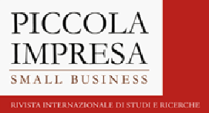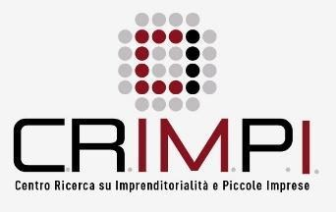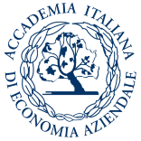

Beyond the crisis: what is the future for small businesses?
Challenges, opportunities and lessons learned

4th PISB Conference
Urbino, 3-4 December 2021

CONFERENCE REGISTRATION

CONTACT INFO
NAME |  | SURNAME

HOME ADDRESS

ZIP CODE

FISCAL CODE

UNIVERSITY

UNIVERSITY ADDRESS

Please attach a copy of your payment.

If a University makes the payment, please send an email to federica.palazzi@uniurb.it before the payment.

